Manila Water CompanyCustomer NameDocument Title

FUNCTIONAL SPECIFICATION – ENHANCEMENT

DID_M2C_169
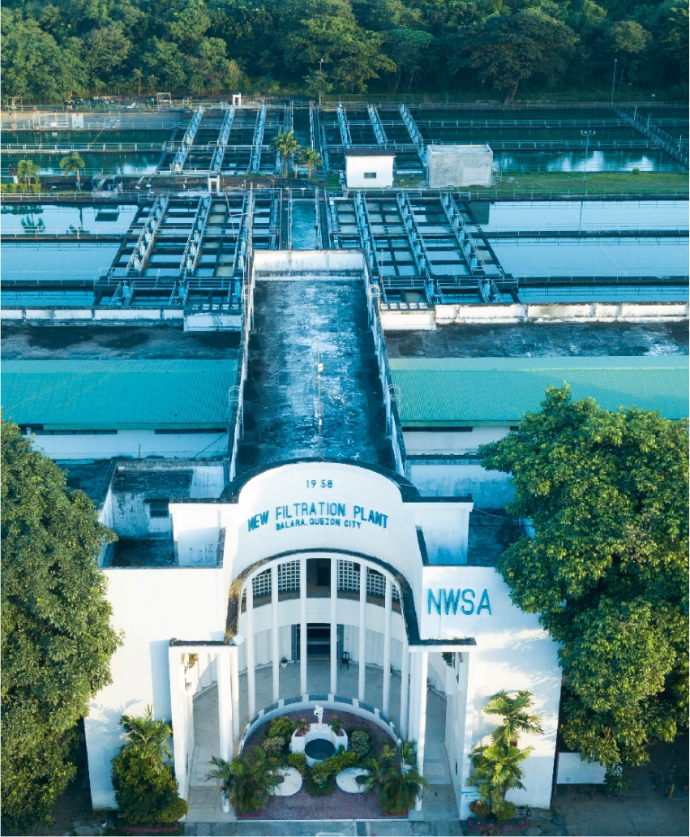





Contents
1 Document Organization 4
1.1 Document Log 4
1.2 Integration, Document Reference 4
2 Justification 5
3 Functional Description 5
4 Security / Authorization Requirements 5
4.1 Definition 5
4.2 Defined Fields 5
4.3 Procedure 5
5 Dependencies / Constraints 5
6 Assumptions 5
7 Security Requirements 5
8 Functional Requirement 6
8.1 Flow of Enhancement 6
8.2 Layout 6
9 Assumptions in Functional Design 6
10 Open Issues in Functional Design 6
11 Business Test Conditions 6
12 Related Documentation 6

Document Organization
This section provides details about this document, previous version(s) of this document and the document(s) referred.

Document Log
Following table mentions the version changes and the processer(s):
Version | Status | Date | Version Created by (Name/E-Mail/Company) | Role | Comments
1.0 | Final | February 17, 2025 | Sudhakaran/ Sudhakaran.m01@sap.com/ SAP | Author
1.0 | Final | February 18, 2025 | Roopali Sharma/ roopali.sharma02@sap.com/ SAP | Reviewer

Integration, Document Reference

S. No. | Referred Document Name | Referred Document Version | Referred Document URL (Optional)

Justification
This requirement requires enhancement since there is no standard duplication check available.

Functional Description

Service request gets created in SAP. This enhancement is to validate and prevent duplication of service request creation for the same issue.
The check is based on customer, checklist, status and the creation date of the request. System will throw an error stating that there is already a request created in the last 7 days on the same subject and will hard stop from saving the new duplicate request.

Security / Authorization Requirements
N/A

Definition
N/A

Defined Fields

Field | Sample Value
SOLD_TO_PARTY | 1000000001
HEADER_GUID | D1B1F813591F1EEFBBA2E159D39FEA10
CHKLST_ID | METER
POSTING_DATE | 17.02.2025

Procedure

Dependencies / Constraints
N/A

Assumptions
This WRICEF is built with the below assumptions.
- All service requests have checklists determined
- All service requests are not in completed status

Security Requirements
N.A

Functional Requirement

BADI : ORDER_SAVE - CHECK_BEFORE_SAVE
Function Module : CRM_ORDER_READ
Table : CRMS4D_SERV_H

Pass IV_GUID from ORDER_SAVE - CHECK_BEFORE_SAVE into CRM_ORDER_READ - IT_HEADER_GUID

Get
ET_ORDERADM_H – POSTING_DATE
ET_SRV_REQ_H – CHKLST_ID
ET_PARTNER – REF_PARTNER_NO where REF_PARTNER_FCT = ‘00000001’

POSTING DATE () = (ET_ORDERADM_H – POSTING_DATE) – 7, .. .

Pass
POSTING DATE () into CRMS4D_SERV_H - POSTING_DATE
ET_SRV_REQ_H – CHKLST_ID into CRMS4D_SERV_H - CHKLST_ID
ET_PARTNER – REF_PARTNER_NO into CRMS4D_SERV_H - SOLD_TO_PARTY

Where
CRMS4D_SERV_H – STAT_LIFECYCLE != ‘C’.

If Entry exists :
Raise exception : IF_EX_ORDER_SAVE - DO_NOT_SAVE
Message class : ZORDER_SAVE – “Request cannot be save since there is already a request created on the same subject within the last 7 days”

Else
Proceed to Save.

Flow of Enhancement
N/A

Layout
N/A

Assumptions in Functional Design
N/A

Open Issues in Functional Design
N/A

Business Test Conditions

Scenario # | Input Selection Criteria | Expected Result
1 | Request 100 created | Request created
2 | Request 101 created on same subject within 7 days | Request aborted

Related Documentation

N/A

